Main Agenda- To show the CARD Number to Customer and to Hide it from the manager

Inn order to achieve this requirement we need to know the access control policy and access control policy and then we need to go with the 2 operators as to customer and manager.

And here we are creating the case type

And in this the first step would be customer entering the information   
  
And in the next screen it would show him the details fully

And after it enters into the review and routed to the manager and after that

And manager is now only able to see 4 digits of the fields

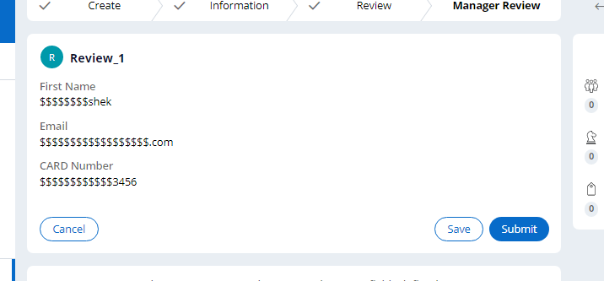

So this is our output

In order to achieve this we need to configure the Access Control Policy with the Property Read as the type because we want property to be masked and get it into the things and we can

Where in we can give the properties for which we want to mask so for this we can give stage pyStatusWork for the condition so that when the status changes then the Condition would apply.

Where in the case status can be changed and we will get the desired output.